Exercise 1: Setting Up JUnit

**Scenario: You need to set up JUnit in your Java project to start writing unit tests.**

<dependencies>

<dependency>

<groupId>org.junit.jupiter</groupId>

<artifactId>junit-jupiter-api</artifactId>

<scope>test</scope>

</dependency>

<!-- Optionally: parameterized tests support -->

<dependency>

<groupId>org.junit.jupiter</groupId>

<artifactId>junit-jupiter-params</artifactId>

<scope>test</scope>

</dependency>

</dependencies> 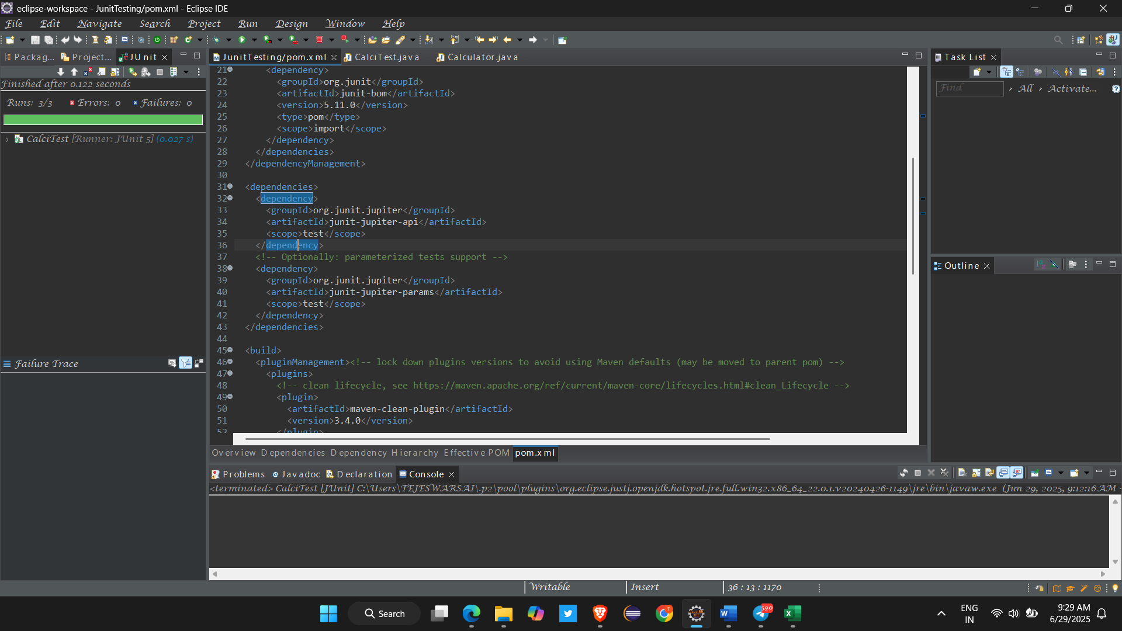

**Exercise 3: Assertions in Junit Scenario: You need to use different assertions in Junit to validate your test results.**

Code :

package com.cognizant.JunitTesting;

import org.junit.jupiter.api.Test;

import static org.junit.jupiter.api.Assertions.*assertEquals*;

import static org.junit.jupiter.api.Assertions.*assertFalse*;

import static org.junit.jupiter.api.Assertions.*assertNotEquals*;

import static org.junit.jupiter.api.Assertions.*assertNotNull*;

import static org.junit.jupiter.api.Assertions.*assertNull*;

import static org.junit.jupiter.api.Assertions.*assertTrue*;

**CalciTest.java**

public class CalciTest {

Calculator calc = new Calculator();

*@Test*

public void testadd() {

int result = calc.add(30, 40);

*assertEquals*(70, result);

*assertTrue*(result>0);

*assertFalse*(result<0);

*assertNotNull*(result);

*assertNotNull*(calc);

}

*@Test*

public void testsub() {

int result = calc.subract(9, 3);

*assertEquals*(6, result);

*assertNotEquals*(9, result);;

}

*@Test*

public void testdiv() {

*assertEquals*(3, calc.divide(9, 3));

}

}

**Calculator.java**

package com.cognizant.JunitTesting;

import java.util.*;

public class Calculator {

public static void main(String args[]) {

Scanner s = new Scanner(System.***in***);

int a = s.nextInt();

int b = s.nextInt();

Calculator cal = new Calculator();

System.***out***.println("Add :" + cal.add(9, 4));

System.***out***.println("Sub :"+cal.subract(9, 8));

System.***out***.print("Mul :"+cal.multiply(8, 5));

}

public int add(int a,int b) {

return a+b;

}

public int subract(int a , int b) {

return a-b;

}

public int multiply(int a , int b) {

return a*b;

}

public int divide(int a , int b) {

return a/b;

}

}

